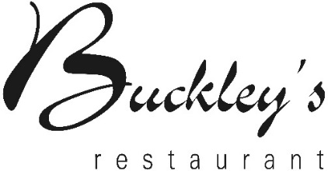




Lunch Menu

To Begin

DUCK
Pressed terrine with liver, apple, peas & parsley

FISH
Salmon fishcake with Dijon mustard & rocket

TOMATO (N) (V)
Veloute of tomato with olive oil, cheese & pesto

The Interval

CHICKEN
Sous vide breast with crackling, pomme puree, broad beans, pancetta & jus

PLAICE
Whole grilled plaice with caper butter, potato salad & samphire

MUSHROOM (V)
Wild mushroom risotto with truffle & parmesan

The End

RHUBARB (N)
Rhubarb mousse with custard, sour rhubarb & hazelnuts

CHOCOLATE
Dark chocolate tart with orange gel & honeycomb

£6.95 Per Person for two courses
£8.95 Per Person for three courses

Contains nuts (N) Vegetarian dish (V)
Please speak to your server as we can sometimes change dishes to accommodate dietary requirements

